HUMAN BIOLOGY

TASK 3: LUNG DISESASES AND TREATMENTS

**LIST A: Chronic Bronchitis**

**WHAT IS CHRONIC BRONCHITIS AND CAUSES**

Chronic Bronchitis is an inflammatory of the bronchioles that usually caused by the viral infection. The main cause for this is mostly smoking which is by far the No.1 cause for chronic bronchitis also include secondhand smoke, premature birth, heart and lung conditions, depressed immune system, transmitted by air bone exposure and indirect contact and the lack of breastfeeding. It is also common for ages 5 and younger. Chronic Bronchitis is easier to catch respiratory infections like cold, flu and pneumonia.

Two main types of bronchitis: acute and chronic. Acute forms a following an upper respiratory infection such as cold. Chronic develops overtime and doesn’t really go away.

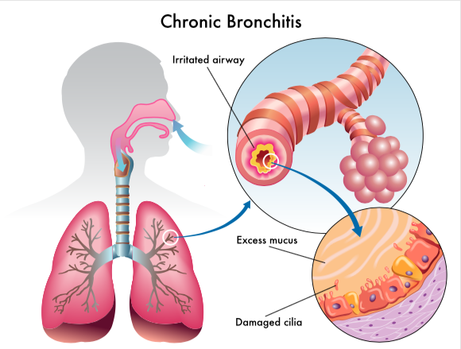

**SYMPOTOMS AND DIAGNOSIS**

Symptoms for the chronic bronchitis are:

* Runny nose
* Stuffy nose
* Slight fever
* Cough
* Wheezing
* Difficulty in breathing
* Middle ear infection (otitis media)
* Loss of fluids

For the diagnosis they do simple common tests and procedures based on the symptoms.

* Auscultation: using the stethoscope, doctor’s listens to the patient’s lung for any abnormal lung sounds (wheezes) which can indicate a disease or problem in the lungs.
* X-ray: to check the traces for pneumonia.
* Vital test: checking for the presence of virus in mucus samples.
* Complete blood count (CBC): checks the count of white blood cells; increased numbers indicate infection.

**TREATMENTS**

1. Therapy

* Oxygen therapy: if severe symptoms are seen, the baby is hospitalised and oxygen is given to improve blood oxygen levels. IV fluids may be given to prevent dehydration.

1. Self-care

* Consume plenty fluids.
* Maintain the health and integrity of every cell in the body.
* Clean any mucus from the nose.
* Does not block anything that are irrelevant in the nose to keep.
* Apply vaporizer while sleeping.
* Using vaporizer for medical herbs, heating the medicine releases the beneficial chemicals as a vapor. While exhaling the vapor it clears out all the mucus.
* Humidify the air to help ease the congestion and coughing.
* Help us breathe well and without us coughing.
* Keep the baby upright to make breathing easier.
* Babies are very delicate, and they help the baby because they’re only tiny and it helps the baby breathe more better.
* Keep the environment free smoke.
* So, it won’t get into our lungs and so we don’t have any diseases inside of us. It helps a lot by saving people too and the world.

1. Aerosol sprays

* Helps relieves symptoms of chronic bronchitis by relaxing and opening the air passages in the lungs.

**PREVENTION**

* Wash your hands thoroughly
* Wash or wipe surfaces and toys
* Keep newborn babies away from people with cold or flu

**LIST B: Pneumonia**

**WHAT IS PNEUMONIA AND CAUSES**

Pneumonia is an infection of the air sacs in one or both the lungs.

It can be caused by bacteria, virus, or fungi. Bacterial and viral pneumonia spread through inhalation of air bone droplets by coughing or sneezing and also may spread through the blood especially during shortly after birth.

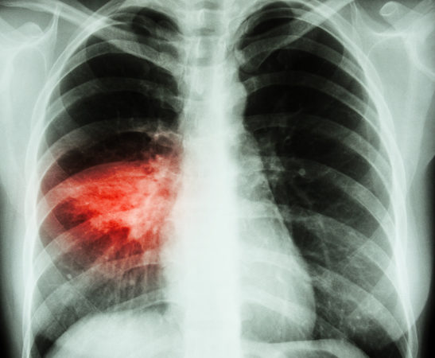

**SYMPTOMS AND DIAGNOSIS**

Symptoms for pneumonia are:

* cough producing mucus
* Fever
* Sweating
* Fast breathing
* Shortness of breath
* Chills, teeth grinding
* Chest pain while coughing
* Fast heartbeat
* Feeling very tired or very weak
* Nausea and vomiting
* Diarrhoea
* Loss of appetite
* Body pain

Diagnosis:

X-ray: chest X-ray is taken to check the presence of infection

Blood culture: check the presence of infection and identity the causative organism.

Sputum culture test: confirm the cause of infection.

Urine test: bacterial infection of streptococcus pneumonia and legionella pneumoniphila can be identified.

Pulse oximetry: to measure oxygen flow to the lungs.

CT scan: scan the chest is performed to detect the severity of infection.

Bronchoscopy: camera fitted tube is inserted into the lungs to look into the airways

**TREATMENTS**

1. Nutrition-

Foods to eat:

* Increase fluid intake; broth based soups provide relief from symptoms
* Plenty of fruits and vegetables
* Lean proteins

Foods to avoid:

* Starch and sugar pasteurized milk and dairy products

1. Medication:

* Antibiotics:

Treat bacterial infection.

* Antivirals

Treat viral infection

* Antifungals

Caused by fungi

* Analgesics

Ease symptoms of pain

* Cough suppressants

To relieve cough

**PREVENTION**

* Preventable in vaccines

**REFERENCES**

<https://www.webmd.com/lung/copd-chronic-bronchitis>

<https://www.medicalnewstoday.com/articles/chronic-bronchitis>

<https://www.mayoclinic.org/disease-conditionos/pneumonia>